Contents

Introduction 2

Problems 2

Solution 2

LEVEL 0 CONTEXT DIAGRAM 3

Level 1 DFD 3

ER Diagram 4

Architectural design 5

Site MAP 5

Steps to use site 6

Testing 6

**Technical Document**

# Introduction

The internet nowadays has a very high impact on our day to day operations and activities; this at the same time brings the need of digital and ecommerce transactions that ensures convenient and accurate transactions between clients and providers.

Three different book suppliers: Banbury, Cerebro and Plutonium initially run their businesses individually on their websites. This leads to a little limitation to the client and the providers in terms of searching and ordering books from the suppliers.

The aim of the new system is to provide a centralized platform under Wordsworth that enables the clients and users search and order books from three different suppliers at the same time instead of visiting individual site for each supplier.

# Problems

* Lack of transparency
* Time consuming while visiting different suppliers
* Improper accessibility
* Lack of communication
* Different system runs on different platforms

# Solution

* cost effective
* interoperability
* Provides high level of accuracy and consistency
* Promotes online business on a centralized platform
* Platform independence
* reusability

# LEVEL 0 CONTEXT DIAGRAM

**CUSTOMER**

**SUPPLIER**

**Report**

Add/update Details

ADMIN

5

0

Search/order

Registration/login

Status

Confirmation

Book details

Order Details

# Level 1 DFD

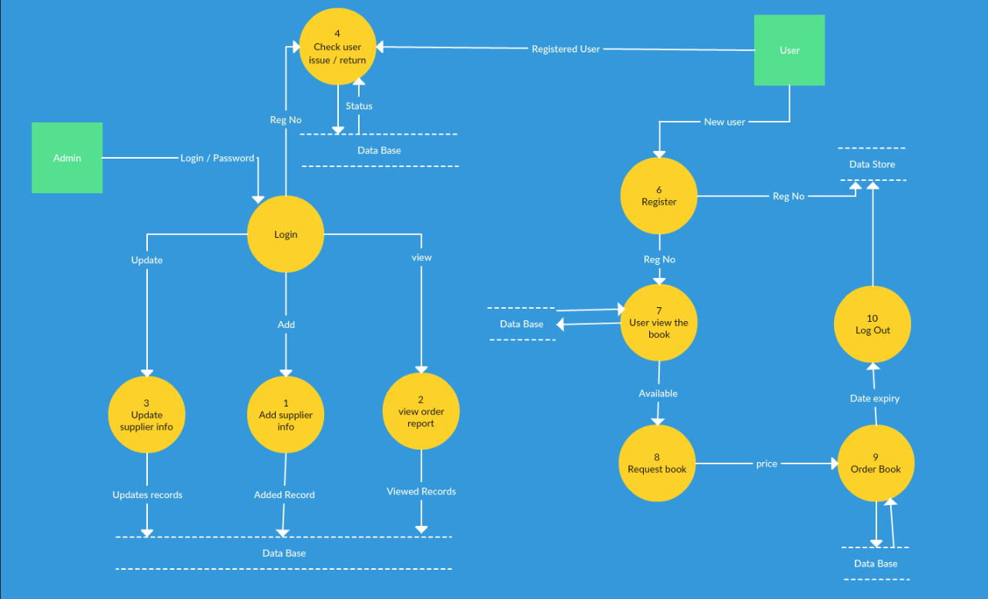

# ER Diagram

Search/Order

Manages

**orderDetails**

Customer

M

**Order**

Payment

Manage

1

view by

Belong

View by

Rent

M

M

11

**Supplier**

Car

M

**User**

Manager

*

*

M

*

M

M

**Admin**

Staff

**Book**

Branch

M

Receives

Register

Makes

Register

Managed d

Property

# Architectural design

**WORDSWORTH**

Banbury

Cerebro

Plutinium

**Description**

As shown above the client contacts the registry which is Banbury(Registry), the registry then contacts the three different suppliers Banbury, Cerebro and Plutonium(Providers) **and finally resent back the result to the client(user).**

# Site MAP

Search

complain

Order

Profile

View users

View complain

Admin Panel

Admin login

View order

Add/edit supplier

User Panel

User login

Register

Login

Search

About

Contact

Index/home

# Steps to use site

* Copy wordsworth folder to C:\xampp2\htdocs
* Start Xampp server
* Start Apache server
* Import databases
* Open web browser and paste “ <http://localhost/wORDSWORTH/AdminWW/php/>”
* The home page should display
* Admin login details
* Username: admin
* Password: 1234

# Testing

Home/index

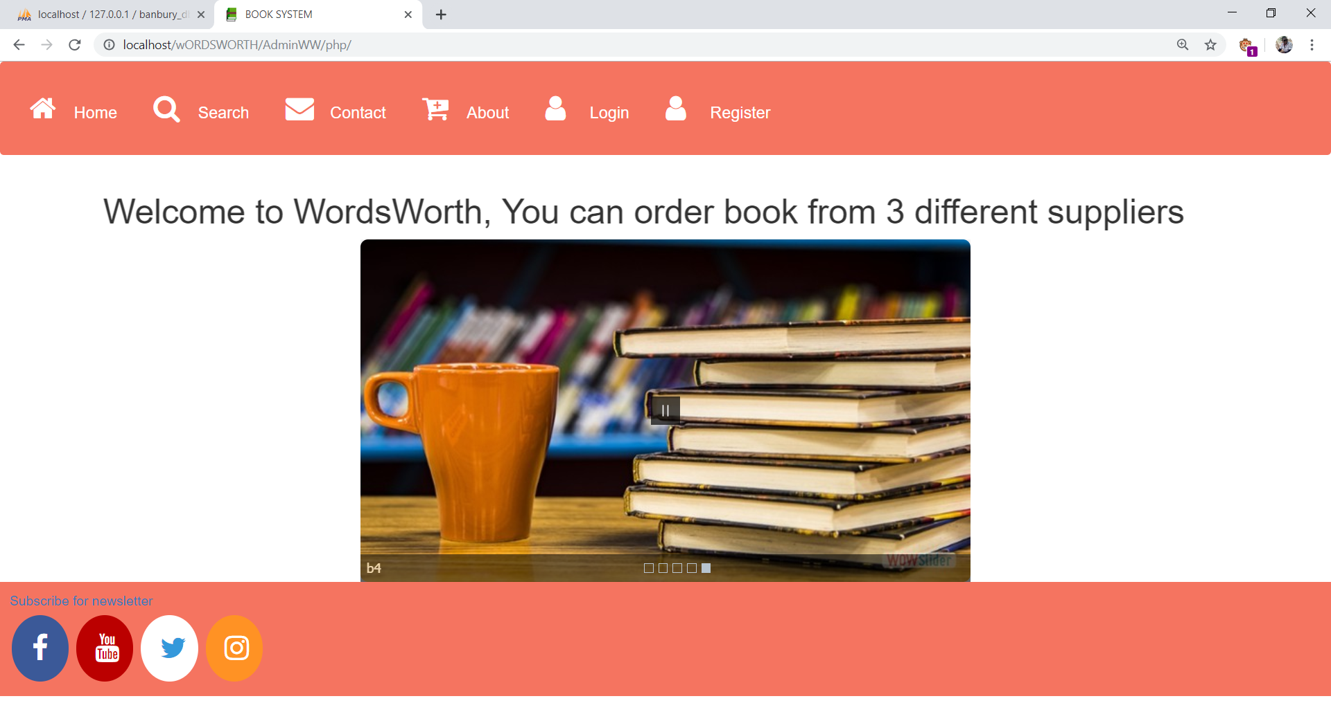

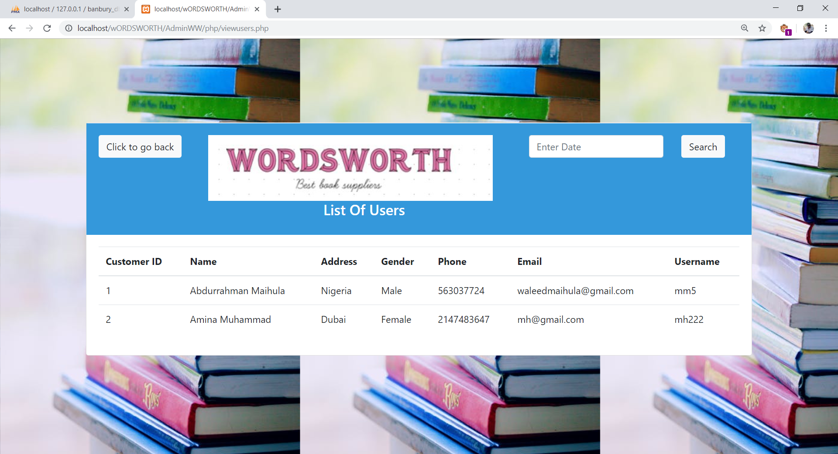users_list

Order_report

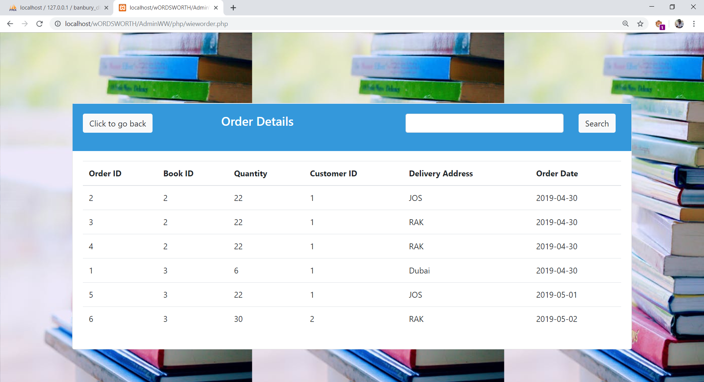

Admin Panel

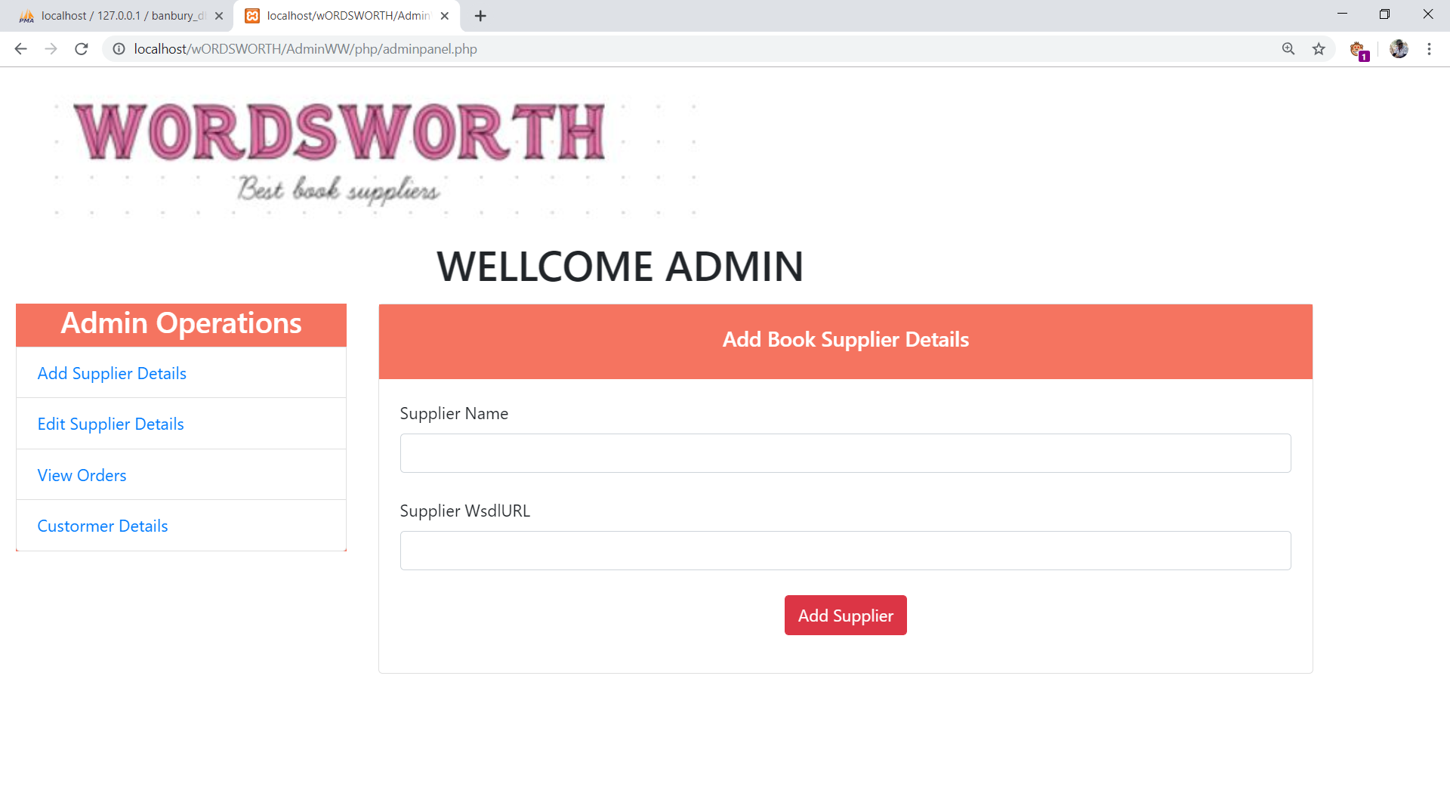

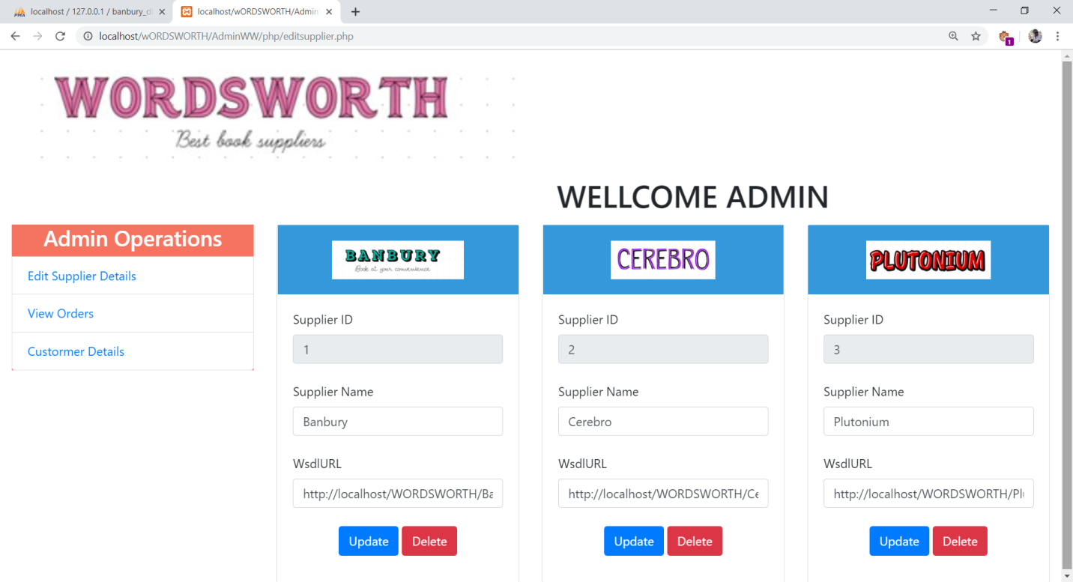update_supplier

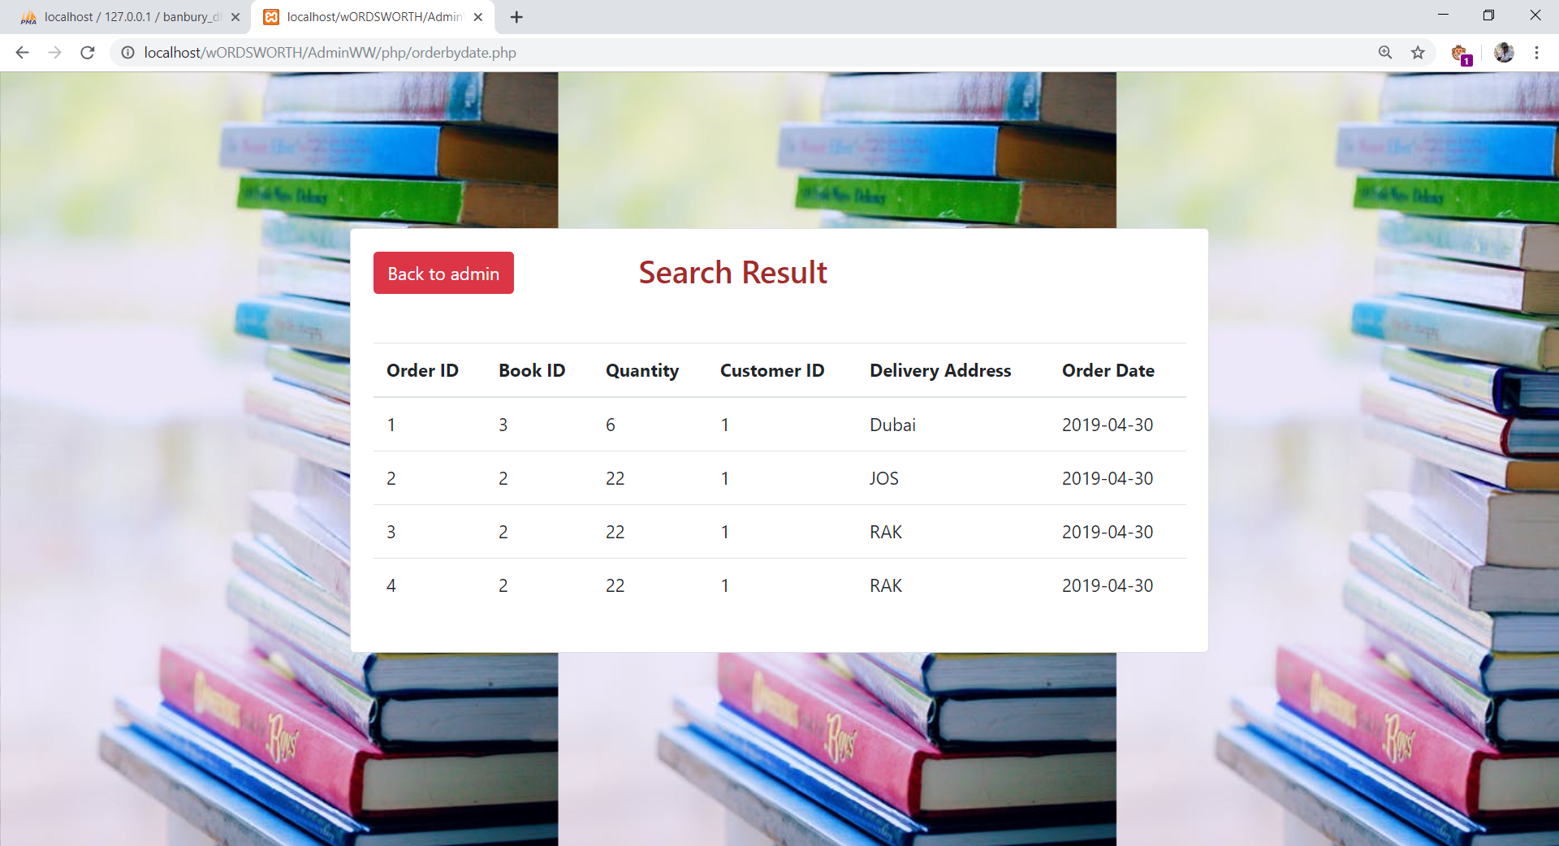order_per_date

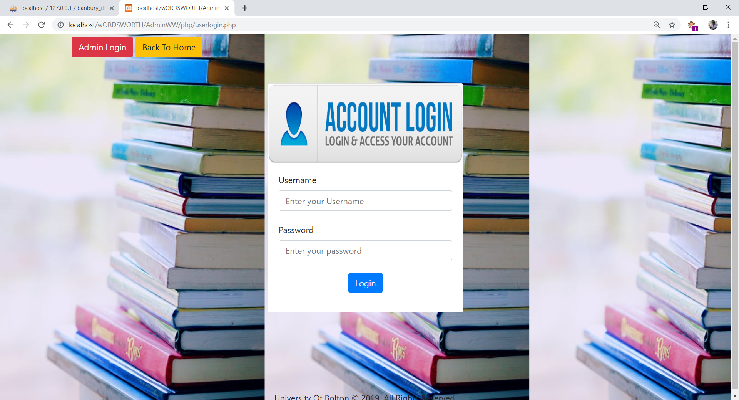

user login

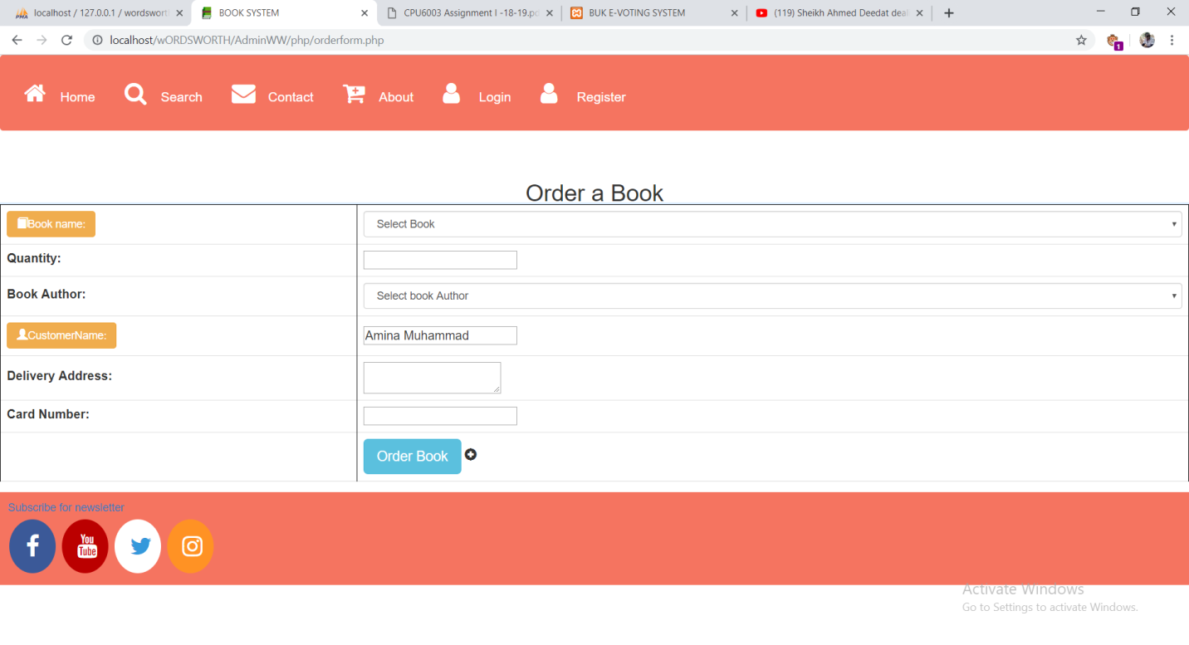order

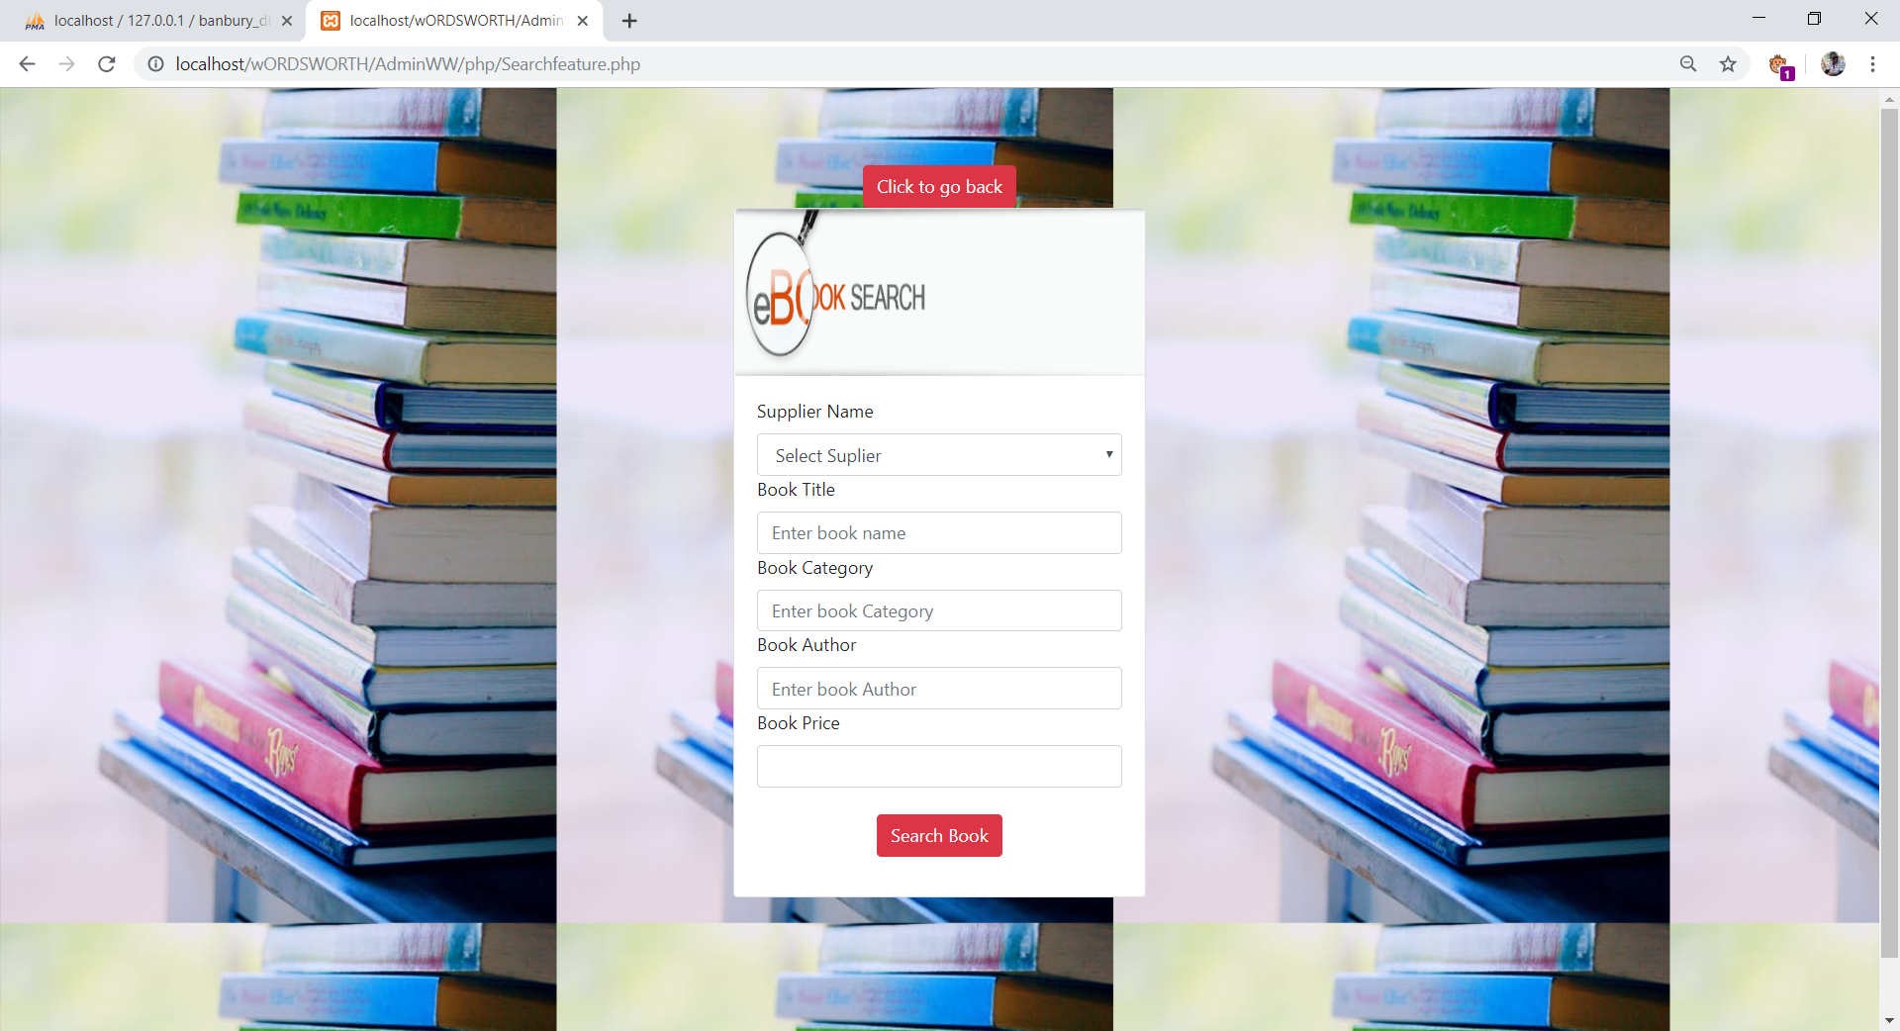search

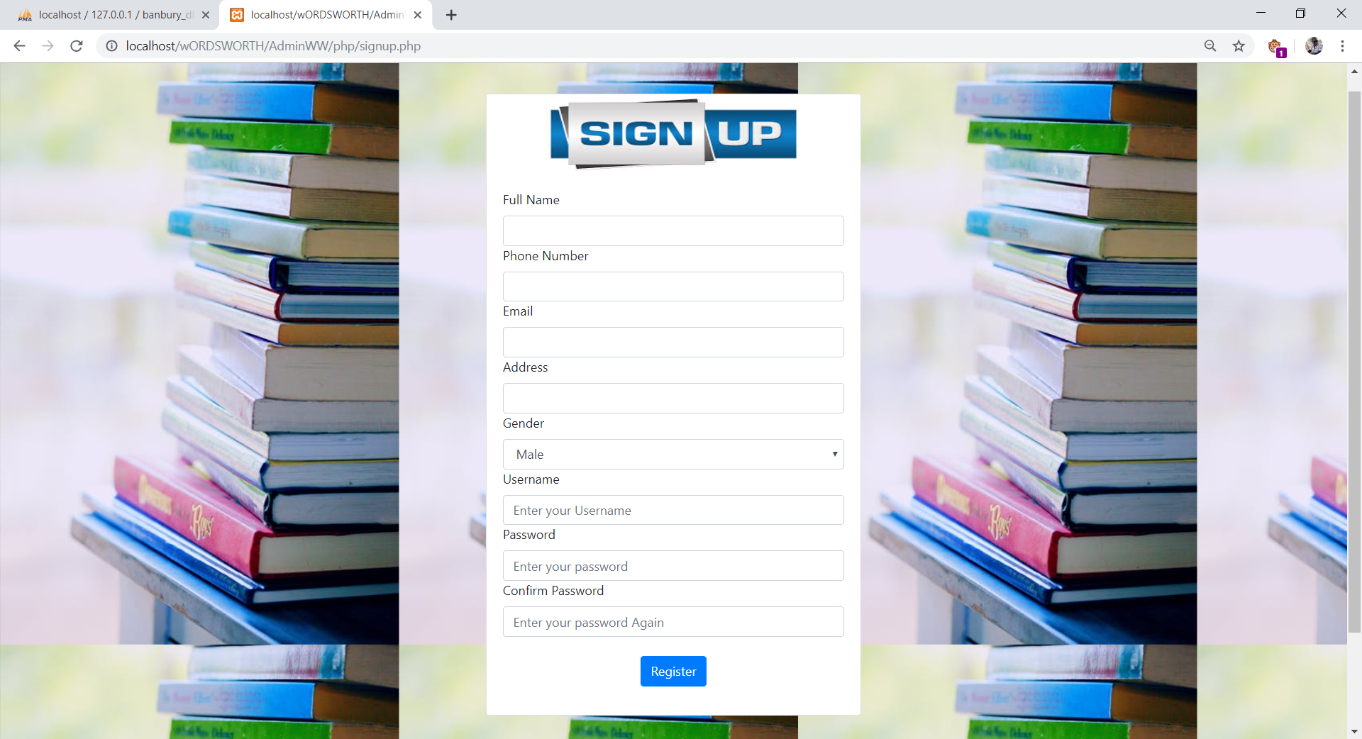registration

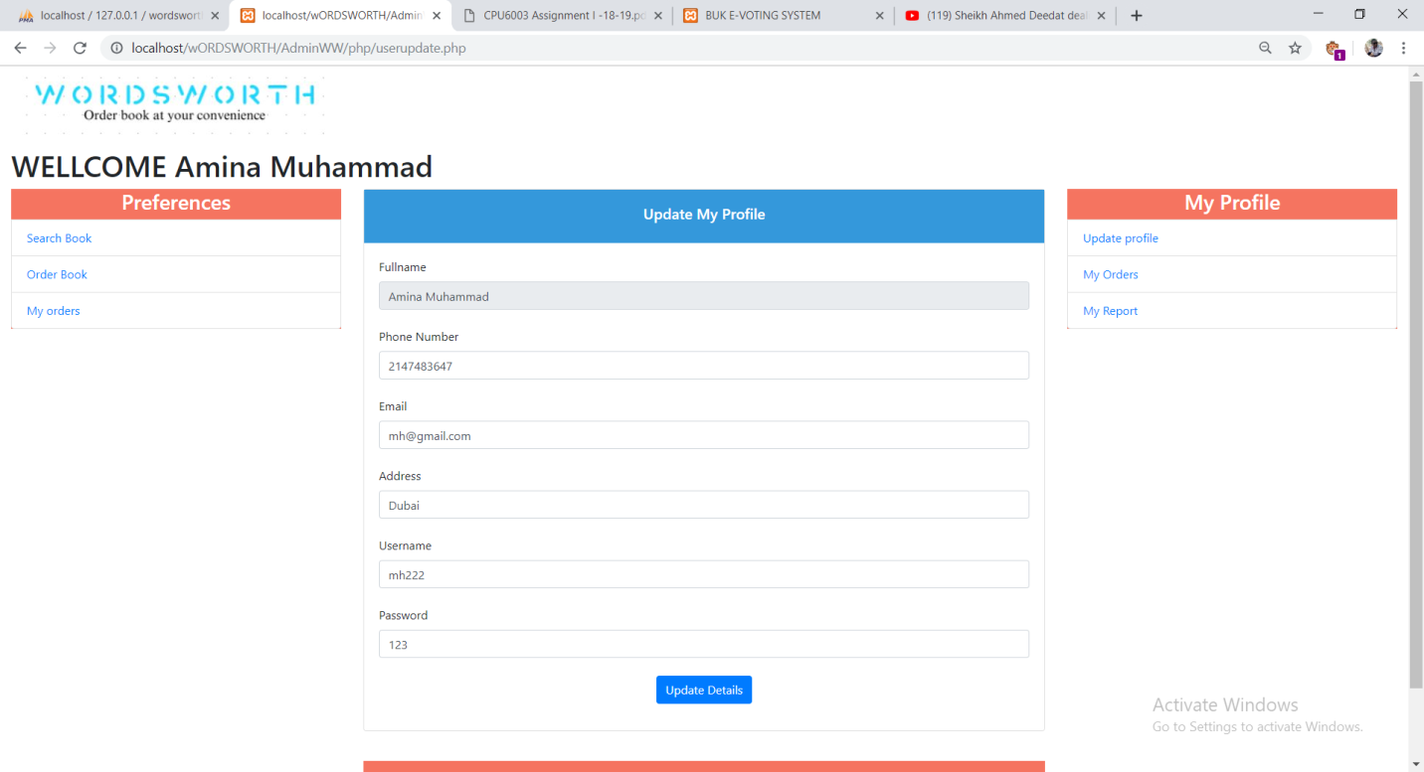

user update

contact

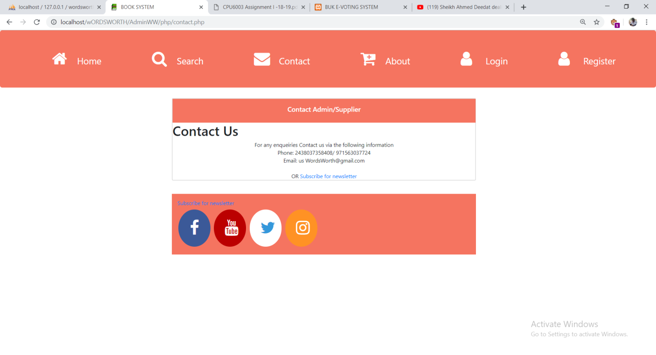

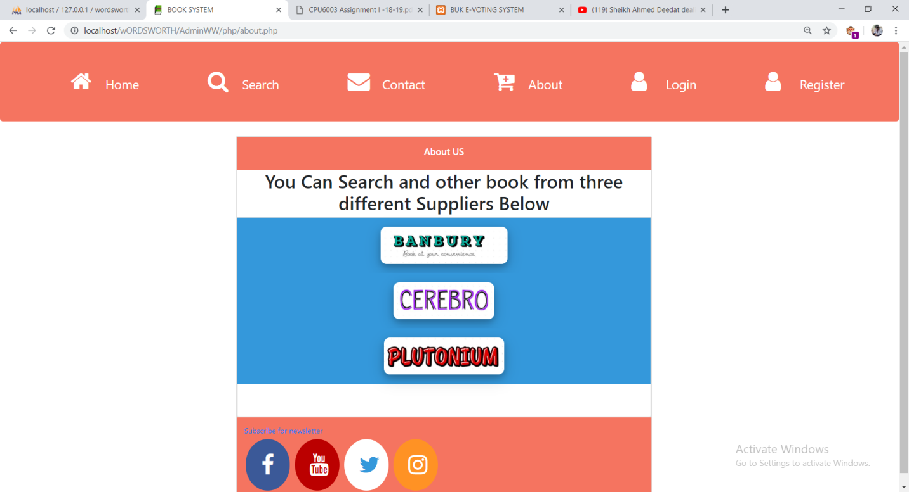About